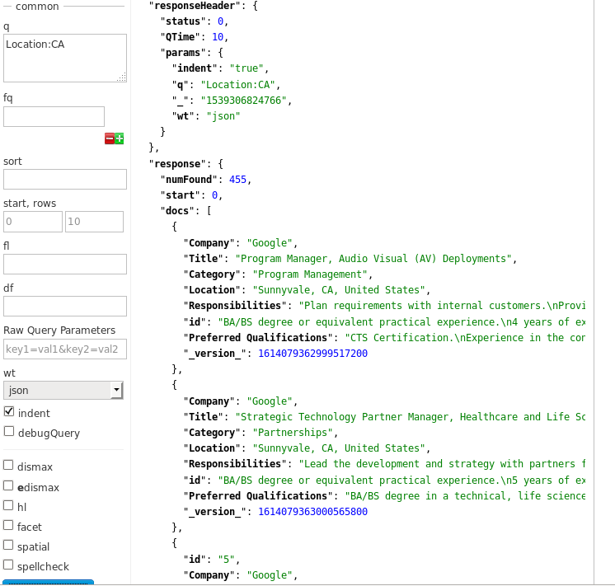

Query 1: Jobs that are in California

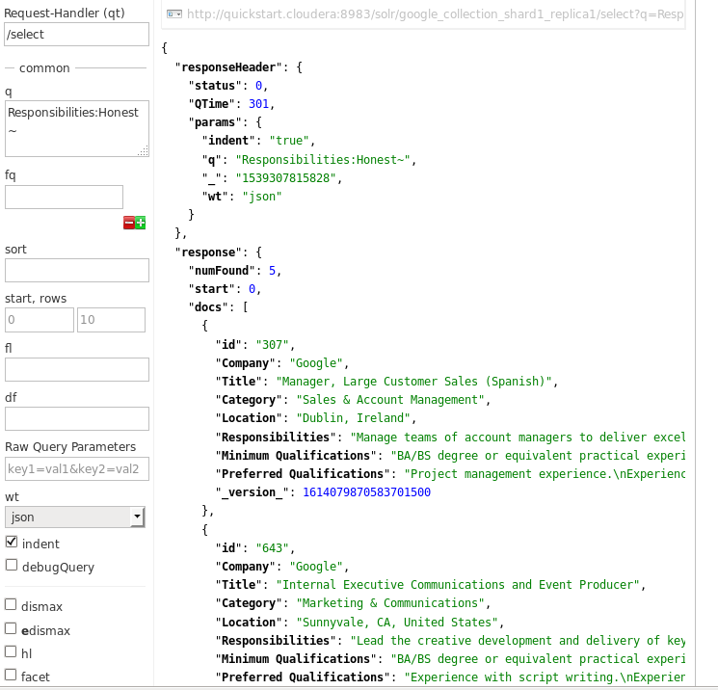

Query 2: Jobs where the Responsibilities include being honest.

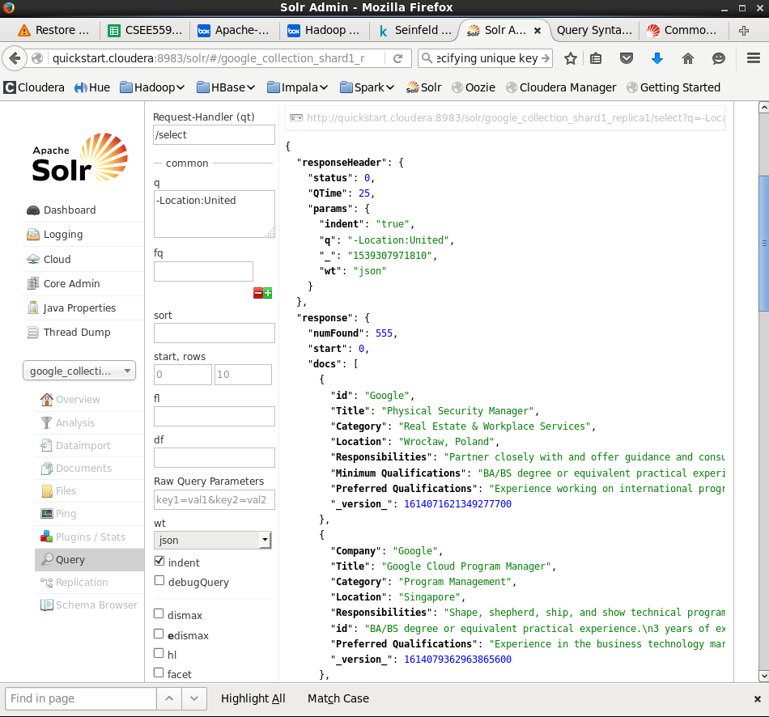

Query 3: Jobs that are located in the United States.

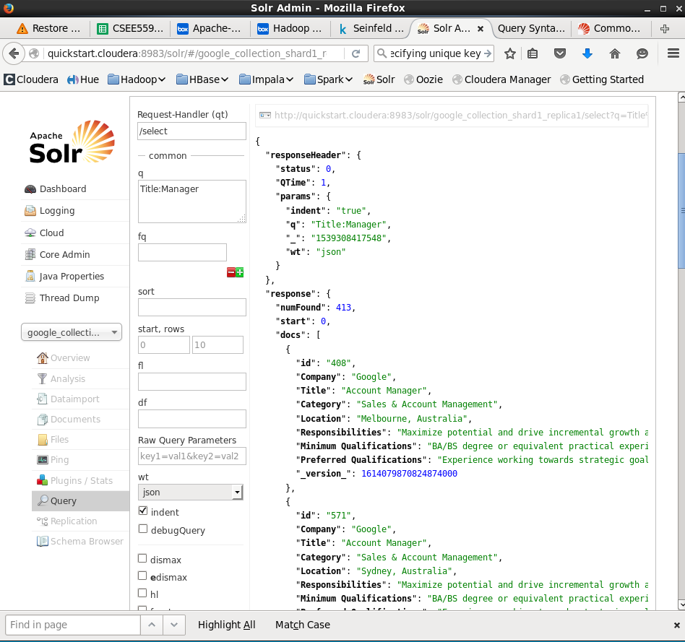

Query 4: Jobs that are for Manager positions.

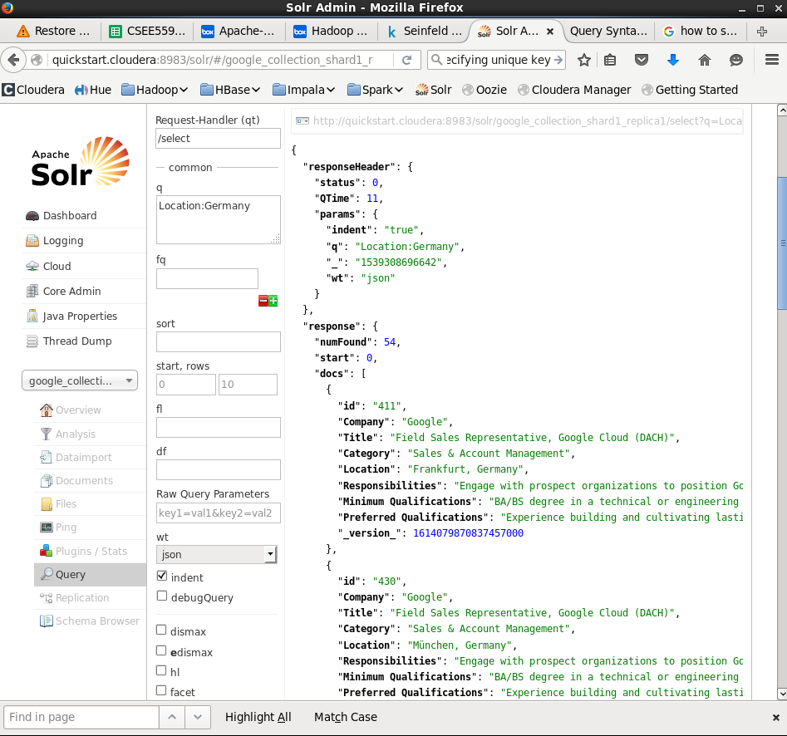

Query 5: Jobs that are located in Germany